Q) Consider an orthogonal cutting operation.What would be average temperature of the shear

zone after unit amount of time of cutting operation? Assume

てs = Force along the shear surface

Vs = Shear velocity

As = Area of the shear plane

f1 = fraction of shear energy converted to heat

f2 = fraction of heat energy released that goes to the shear zone

TR = Room temperature

TF = Final temperature of the shear zone after unit time of cutting operation

s = Specific heat capacity of the material

Assume unit mass of material

(a.) ( (てs As Vs f1 f2 ) / s ) + TR  = TF

(b.) ( (てs As Vs f1 f2 ) / s ) - TR  = TF

(c.) ( (てs Vs f1 f2 ) / (Ass) ) + TR  = TF

(d.) ( (てs As Vs f1) / s ) + TR  = TF

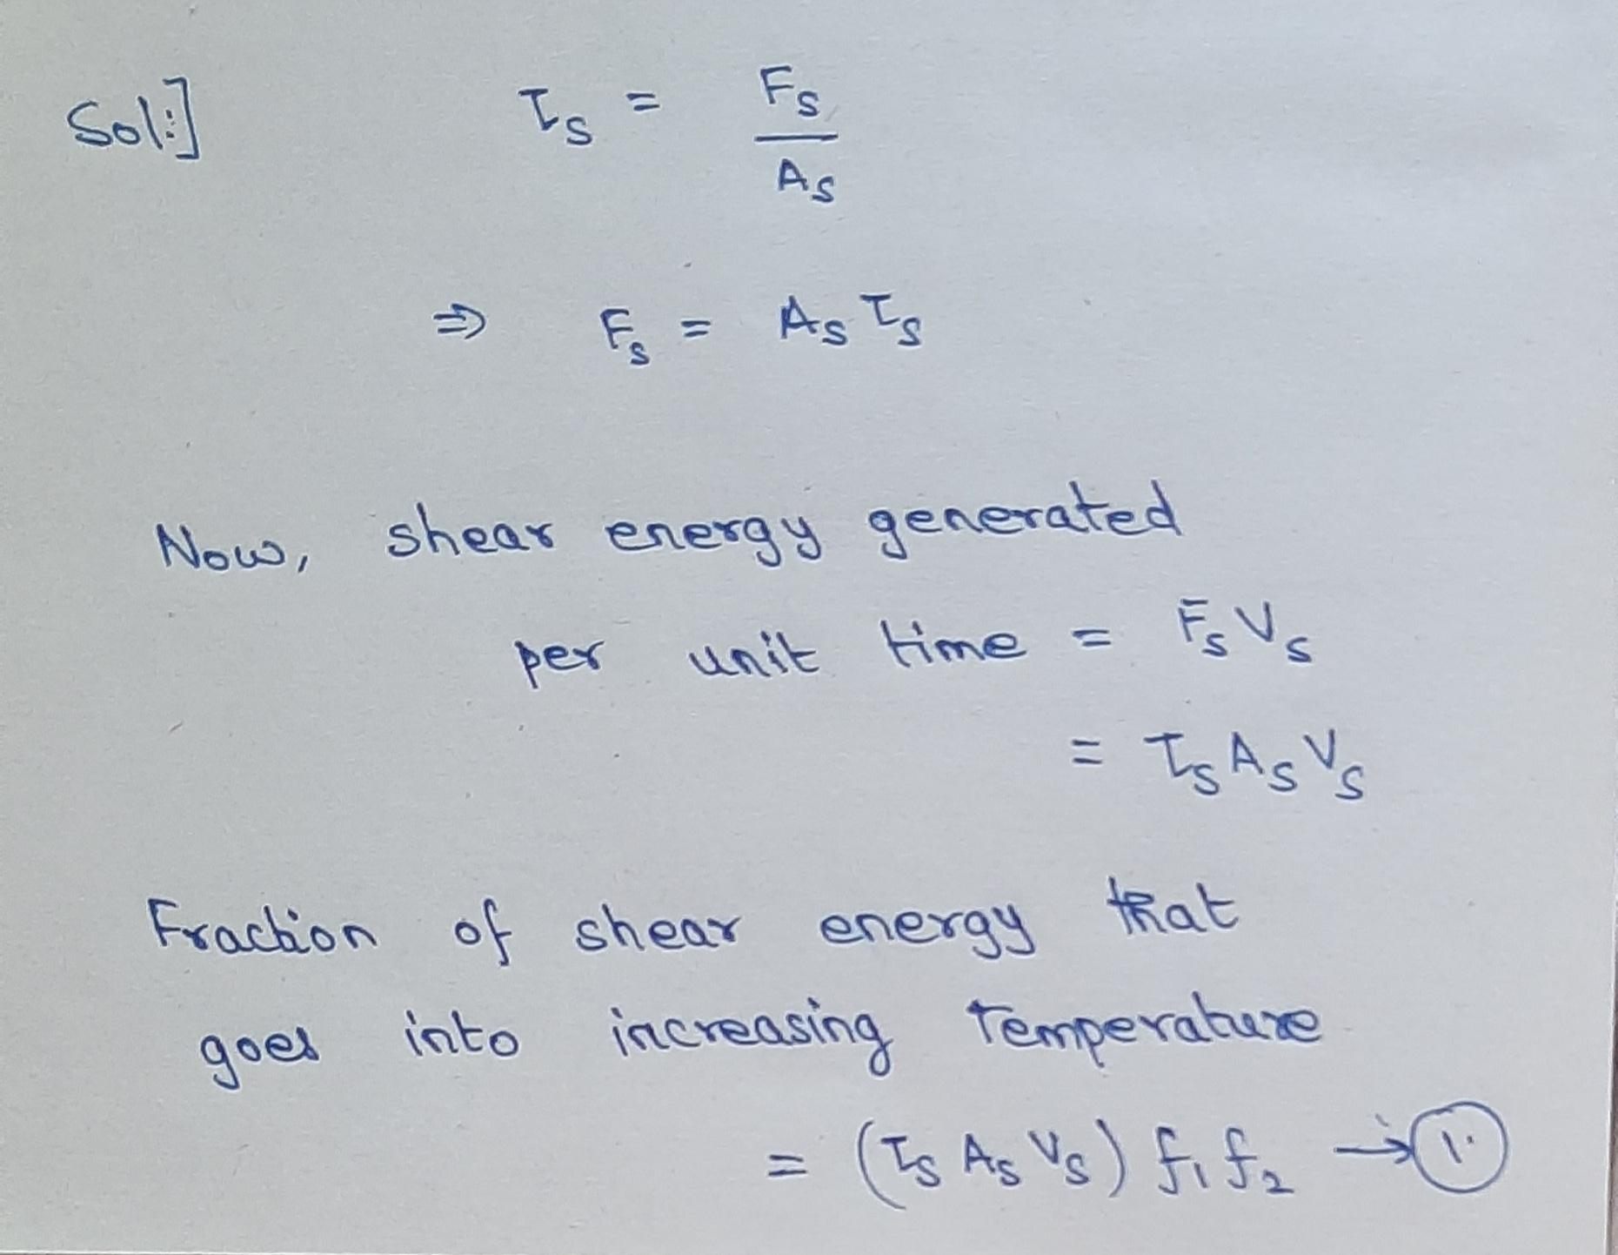

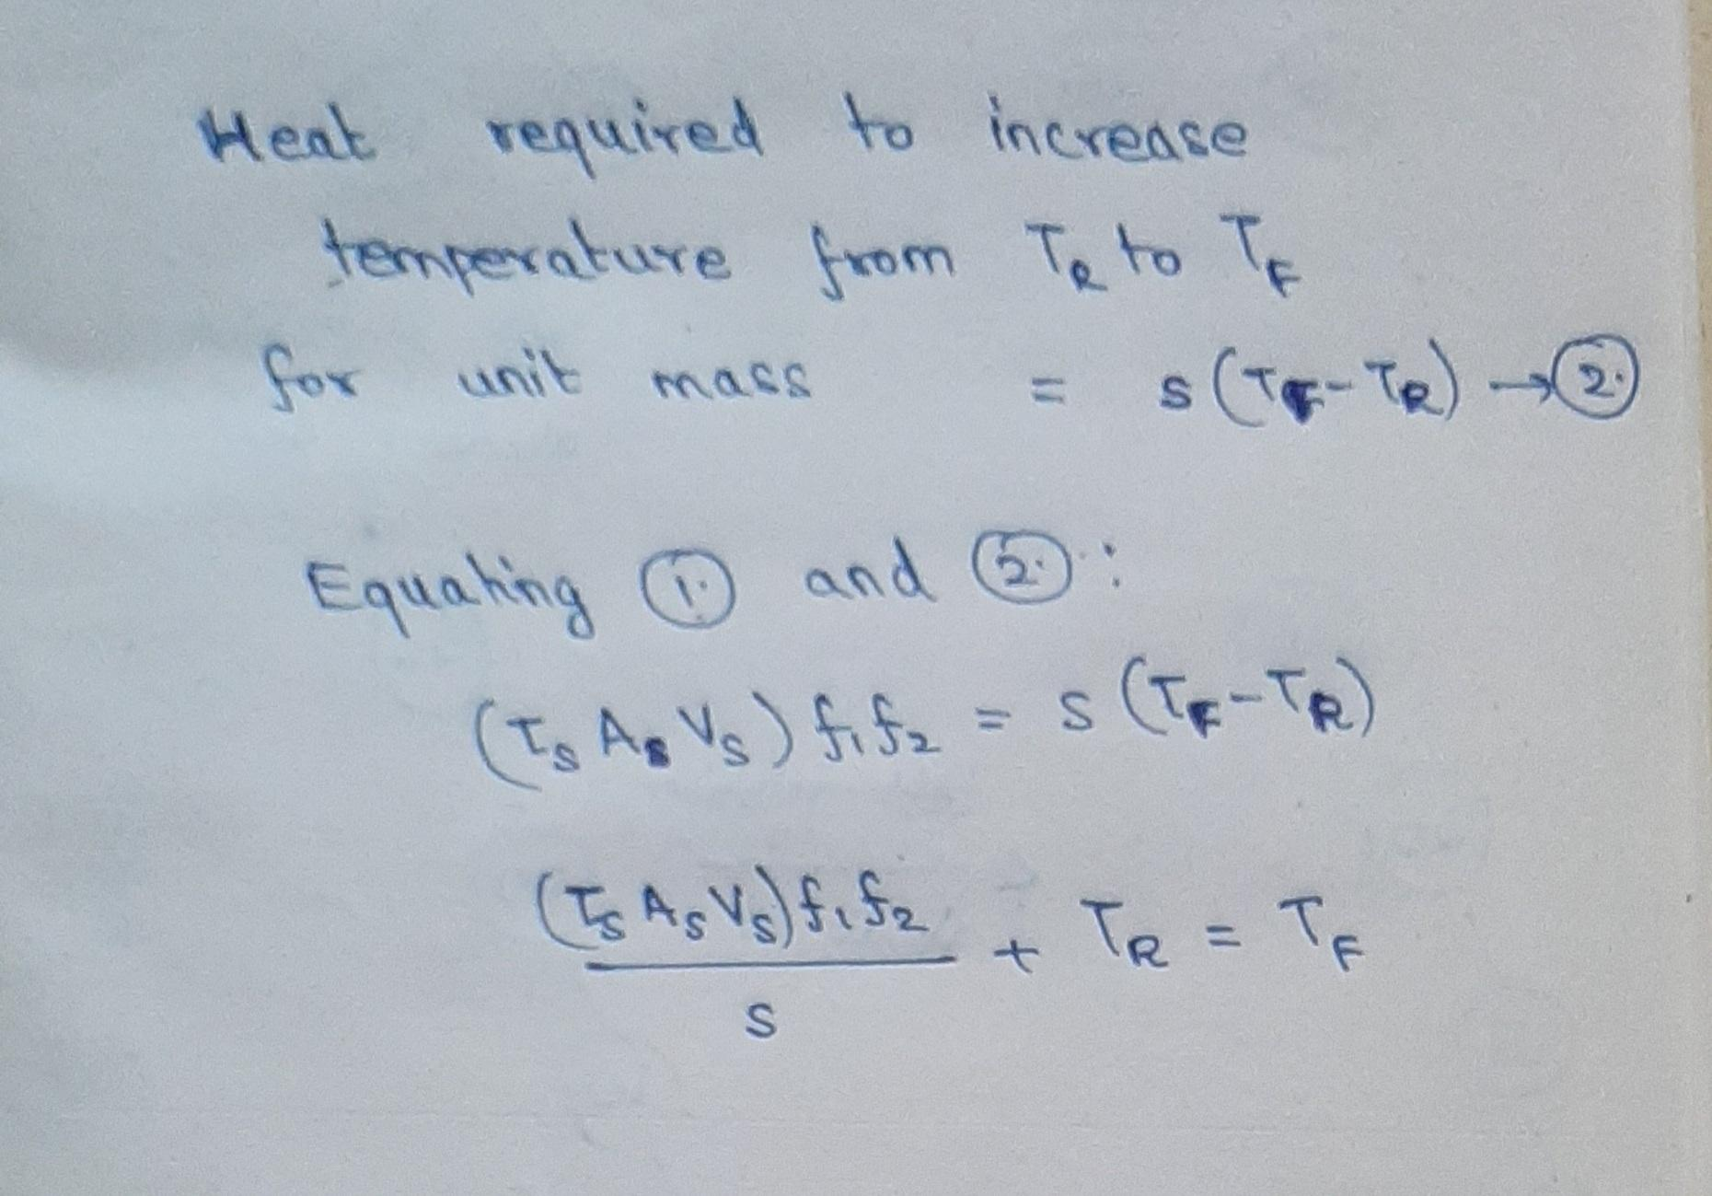

Hence the correct option is (a.)